Below is a graph showing the absorption spectrum of chlorophyll a and the absorption spectrum of chlorophyll b.
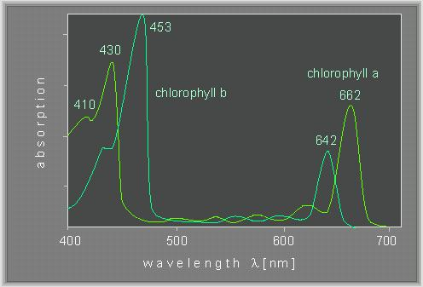
Source of image: http://www.biologie.uni-hamburg.de/b-online/e24/3.htm
- Explain the technique used to determine ‘absorbance’. (3)
A colorimeter/spectrophotometer is used;
A coloured light source originates on one side of the solution;
A detector on the other side of the solution measures the intensity of light that has passed through the solution;
Fraction of light reaching the detector is transmittance;
Fraction of light not reaching the detector is absorbance;
- Compare the absorption spectra of the two chlorophylls. (4)
Both have peaks between 430-450 nm/ blue;
Both have peaks between 640-660 nm/red;
chlorophyll
- Predict, giving a reason, the colour of a solution of chlorophyll a. (2)
Green;
Colour of light passing through the solution/ not absorbed by the solution;
Colour reaching the eye will be green therefore object is perceived as green;

Pictured below is a chromatogram created from spinach leaf extract. The top of the carotene band represents the highest point reached by the solvent.
The ratio of the distance migrated by the pigment to the distance migrated by the solvent is called the R_{f} value.

R_{f} = distance pigment travels
distance solvent front travels

For each of the pigments, calculate the R_{f} value.
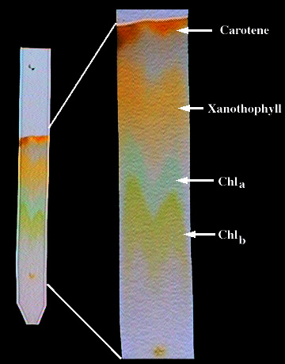
Source of image: http://www.regentsprep.org/regents/biology/units/homeostasis/processes.cfm

