Below is a graph showing the absorption spectrum of chlorophyll a and the absorption spectrum of chlorophyll b.
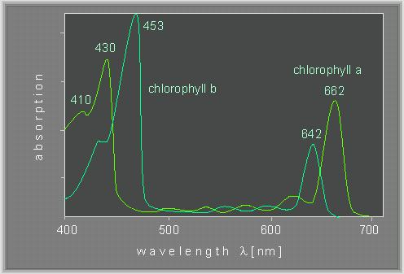
Source of image: http://www.biologie.uni-hamburg.de/b-online/e24/3.htm
- Explain the technique used to determine ‘absorbance’. (3)
A colorimeter/spectrophotometer is used;
A coloured light source originates on one side of the solution;
A detector on the other side of the solution measures the intensity of light that has passed through the solution;
Fraction of light reaching the detector is transmittance;
Fraction of light not reaching the detector is absorbance;
- Compare the absorption spectra of the two chlorophylls. (4)
Both have peaks between 430-450 nm/ blue;
Both have peaks between 640-660 nm/red;
chlorophyll
- Predict, giving a reason, the colour of a solution of chlorophyll a. (2)
Green;
Colour of light passing through the solution/ not absorbed by the solution;
Colour reaching the eye will be green therefore object is perceived as green;

